Visualization with Excel Tools and Windows Azure

# Introduction

Power Query and Power Map are two add-ins that are available as free downloads from Microsoft to enhance the data access and data visualization capabilities of Microsoft Excel 2013. You can use Power Query to retrieve data from a variety of data sources and integrate that data as part of an Excel data model.

# Prerequisites

Your computer must be running one of the following operating systems:

* Windows Server 2008 R2 (with Microsoft .NET Framework 4.0)
* Windows 7
* Windows 8

In addition, you must install one of the following versions of Microsoft Office on your computer:

* Office Professional Plus 2013
* Office 365 ProPlus
* Office 365 Midsize
* Office 365 E3, E4, A3, A4, G3, or G4

Although a 32-bit version is available, you should use a 64-bit computer if you will be analyzing large volumes of data. With a 32-bit computer, you need a minimum of 1 GB of RAM, but a 64-bit computer should have 2 GB of RAM.

Your computer must have Internet connectivity to use Power Map.

# Installation

The first step is to download the add-ins from the Microsoft Download Center. Use the following links:

* Power Map: <http://www.microsoft.com/en-us/download/details.aspx?id=38395>
* Power Query: <http://www.microsoft.com/en-us/download/details.aspx?id=39379>

Locate the downloaded files on your computer’s file system and double-click each file to start the respective installation wizard. Follow the instructions to complete each wizard. Your computer must be connected to the Internet during installation as additional files might need to be downloaded by the installer.

# Power Map

Power Map provides a new perspective for your data by plotting geocoded data onto a three-dimensional view of the earth and optionally showing changes to that data over time. To use Power Map, you import raw data into a Microsoft Excel 2013 workbook, add the data to an Excel data model, and enhance the data in the data model if necessary. Once the data model is prepared, you can then insert a Power Map into the workbook and add items from the data model for viewing on the map. You start by identifying the geographical elements in your data model, select the numeric data to display as well as an aggregation function like sum or count, and then you specify a visualization method such as a column chart, bubble map, or heat map. If your data model includes a date data type, you can identify the date as a time element and then use the map’s play axis to view location changes to the numeric data over time.

To try out Power Map yourself, download the [Mako_Real_Actual_Sharks](http://www.layerscape.org/File/Download/27eb8120-d53b-4f14-a9e3-d5bd04f67dd9/Mako_Real_Actual_Sharks.csv) file to your computer. Next, open a blank workbook in Microsoft Excel 2013 and import the downloaded file by clicking the Data tab and then clicking the From Text button on the ribbon. Navigate to the location to which you saved the downloaded file and double-click the file name to open the file. In the Text Import Wizard, select the My Data Has Headers check box, and then click Next. On the next page of the wizard, select the Comma check box, click Next, and then click Finish.

In the Import Data dialog box that displays next, select the Add This Data To The Data Model check box, as shown in Figure 1, and then click OK. The data imports into a table on the current worksheet and is added to the data model.

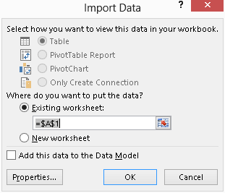

Figure 1: Import Data Dialog Box

If the data were clean, you would be ready to add the Power Map at this point. However, the date and time in the second column is not identifiable as a time data type to Power Map, so you must manipulate the data model using PowerPivot, another data analysis feature built into Excel 2013, before you can create a map. To do this, open the PowerPivot tab on the ribbon.

**Note:** If you do not see the PowerPivot tab, click File on the menu, and then click Options. In the Excel Options dialog box, click Add-Ins in the navigation panel on the left. In the Manage drop-down list at the bottom of the dialog box, select COM Add-Ins and click Go. In the COM Add-Ins dialog box, select the Microsoft Office PowerPivot for Excel 2013 check box, and then click OK.

On the PowerPivot tab, click the Manage button. A new window displays with another copy of the data you just imported, but here you are designing the model rather than working directly with the data. You can observe changes to the data model as you work, but you cannot change the data itself. By using PowerPivot, you can enhance the data by adding more columns to handle data typing issues or to perform new calculations.

For this demonstration, the goal is to derive a date column based on the date and time that displays in the second column. In the sixth column labeled Add Column, click in the cell on the first row to activate the formula bar. Next, type in the formula bar the following expression:

=left([time], 10)

When you press Enter, the formula is evaluated for each row in the table, as shown in Figure 2. By using the Left() function, you have modified the data in the second column to include only the date portion. A new column in the data model now exists and the resulting data will be stored in the workbook along with the data imported from the CSV.

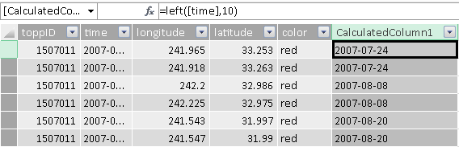

Figure 2: New Calculated Column in Power Pivot

Rename the new calculated column by right-clicking the column header entitled CalculatedColumn1. On the submenu, select Rename Column, type Date, and then press Enter. Now your data is ready to map. You can return to the Excel worksheet by pressing Alt+Tab until you reach the worksheet or click the Excel icon in the Quick Access Toolbar in the top left corner of the PowerPivot window. You should see the new Date column display in the table of the current worksheet.

Although the new column resembles a date, the data type for this column is a string. That means you will not be able to use this column’s values for time series analysis until you make one more adjustment. If necessary, click the column header to select the column and then, in the Data Type drop-down list in the ribbon, select Date. This adjustment modifies the column contents to show the date at midnight, as shown in Figure 3.

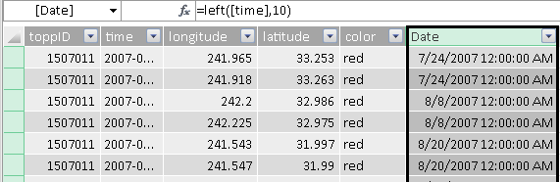

Figure 3: Assignment of Date Data Type

Open the Insert tab of the ribbon, click the Map button, and then click Launch Power Map. A new window opens after a few seconds. Power Map attempts to detect geocoded data in your data model, as shown in Figure 4, and performs a simple mapping. If necessary, you can change the check box selections for geographical fields in the Task Panel on the right side of the screen. In addition, if Power Map fails to correctly identify the type of data that the selected fields represent, you can assign the field to an applicable type from the drop-down list to the right of the field in the Geography And Map Level section of the Task Panel.

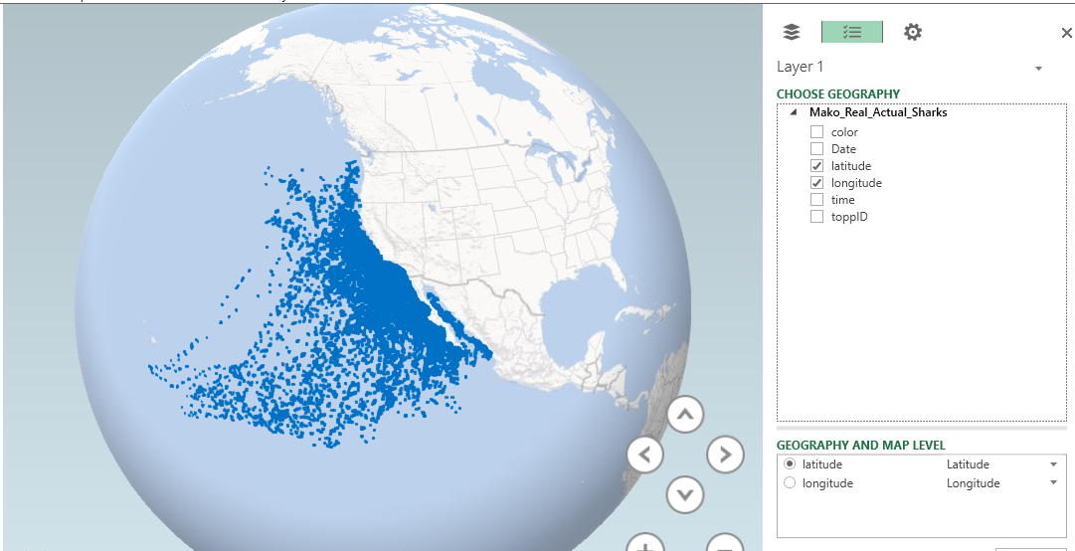

Figure 4: Geography Selection

Click the Next button in the bottom right corner to continue defining the map properties. You now specify the type of chart to display by choosing one of the following options from the Type drop-down list: Column, Bubble, HeatMap, or Region. For this demonstration, keep the default selection of Column.

Your next step is to specify the field containing the numeric value to aggregate and visualize on the map as a column. In the case of the shark data, there is no numeric value available, but you can select the toppID field, which represents an individual shark, to add it to the Height section of the Task panel. The default aggregation is Sum, but you can click the arrow icon to the right of toppID and change the aggregation to Count (Distinct).

The map adjusts to show columns representing the count of sharks in each location, but the data model contains another variable to help us better visualize the shark population. Select the color check box and notice that it now displays as a category. The map now displays columns with multiple colors and a legend lists each color next to the color to which it corresponds on the map, as shown in Figure 5. You can close the legend by hovering the mouse over the legend, and then clicking the X that displays in the top right corner.

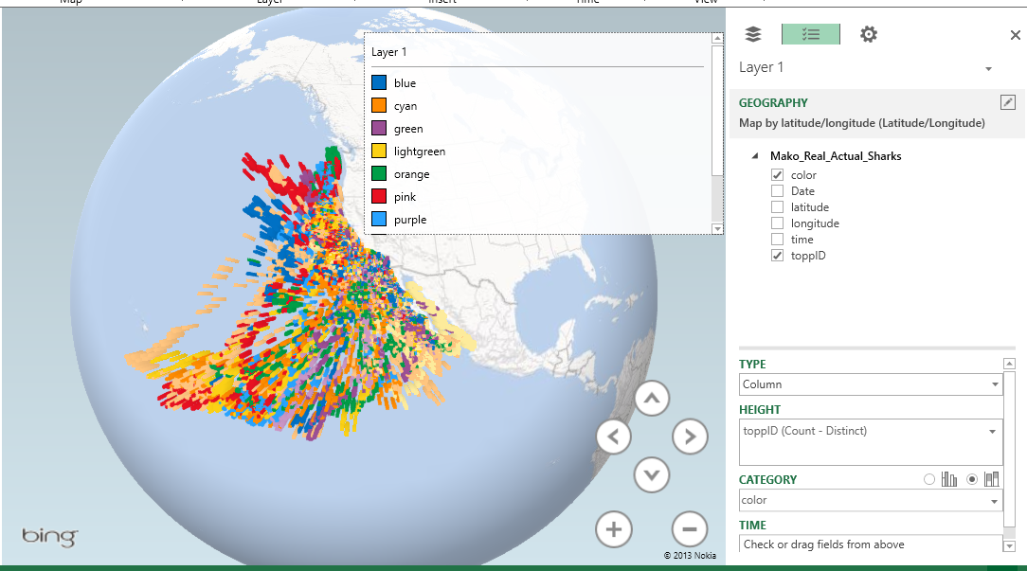

Figure 5: Layer Definition

**Note:** In this example, the colors in the legend are not consistent with the labels because Power Map understands the color values from the data set as text labels with no meaning rather than specific colors.

The settings you configure here are associated with Layer 1. Click the Add Layer button in the toolbar to add a new layer and begin the process again by selecting geographical fields first. You can click the icon in the top left corner of the Task Panel to control which layers are visible. For example, you could obtain data related to sea temperatures by date and include that in the model, allocating the shark movement data to Layer 1 and the temperature data to Layer 2.

You can visualize changes to the data over time by adding a play axis to the map. To do this, drag Date from the model’s field list to the Time box in the bottom right corner of the window. A play axis displays below the map. When you click the play button on the left side of the play axis, the map renders the data points applicable to the current date playing. In addition, you can use the arrow buttons in the bottom right corner of the map to rotate the angle of the view or use the plus or minus buttons to change the zoom factor.

Try changing the Type to a different selection to observe the results.